**1.QUESTION**: WRITE A C PROGRAM TO FIND THE NUMBER OF DIFFRENT BANGLADESHI TAKA NOTE FROM AN INTEGAR NUMBER.

**1.ANSWER:**

**# C PROGRAMMING With Output:**

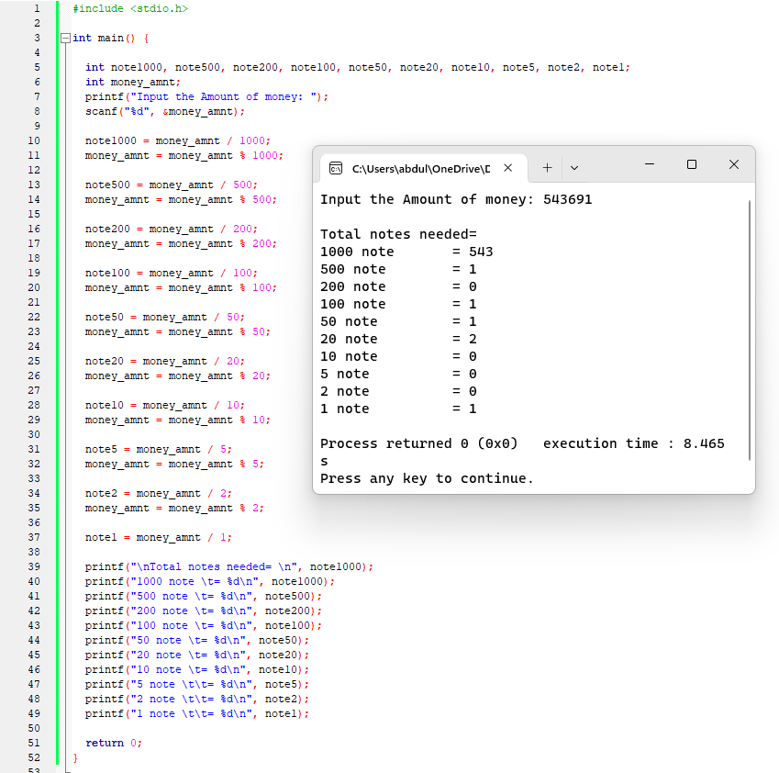

**2.QUESTION**: WRITE A PROGRAM IN C TO CONVERT YOUR HEIGHT FEET AND INCH INTO CENTIMETER.

**ANSWER:**

**# C PROGRAMMING With Output**

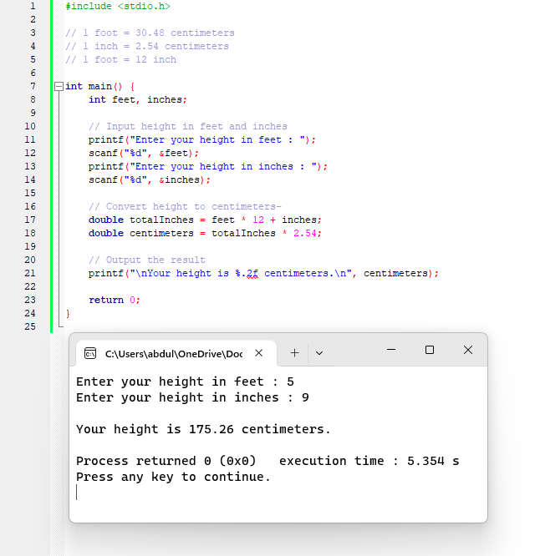

**3.QUESTION**: WRITE A PROGRAM IN C TO CONVERT YOUR HEIGHT CENTIMETER INTO FEET AND INCH.

**ANSWER:**

**# C PROGRAMMING With Output**

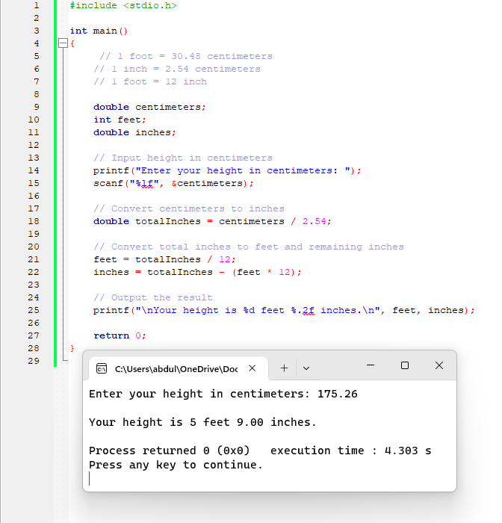

**4.QUESTION**: WRITE A PROGRAMM TO SEE THE ASCII VALUE OF A CHARACTER.

**ANSWER:**

**# C PROGRAMMING With Output**

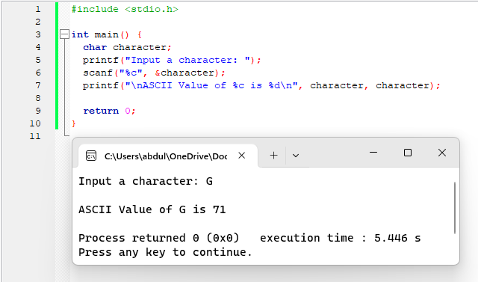

**5.QUESTION**: WRITE A PROGRAMM TO FIND CHARACTER FROM ASCII VALUE.

**ANSWER:**

**# C PROGRAMMING With Output**

